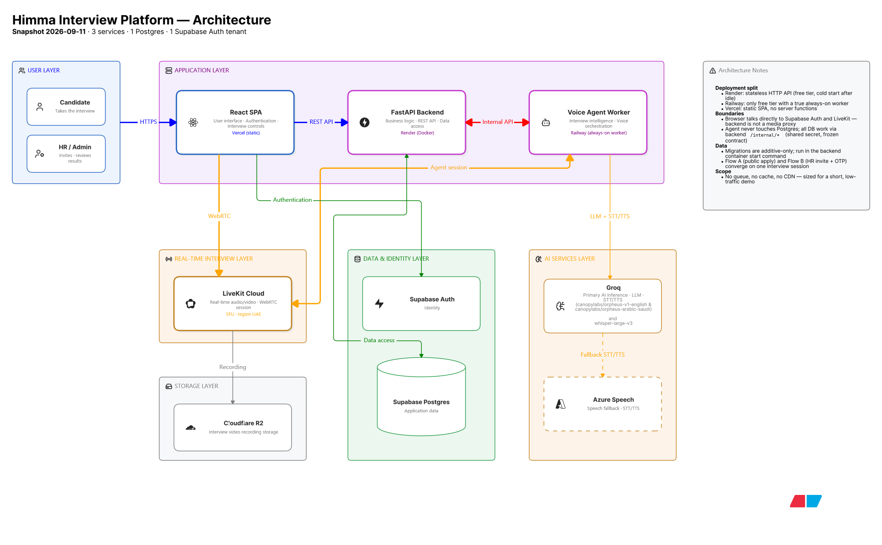
Himma is an AI-powered hiring platform that automates first-round interviews through live voice conversations.
It gives every candidate a consistent interview experience, generates structured assessments and scorecards, and helps HR compare candidates fairly.
AI conducts the interview. Humans make the final hiring decision.
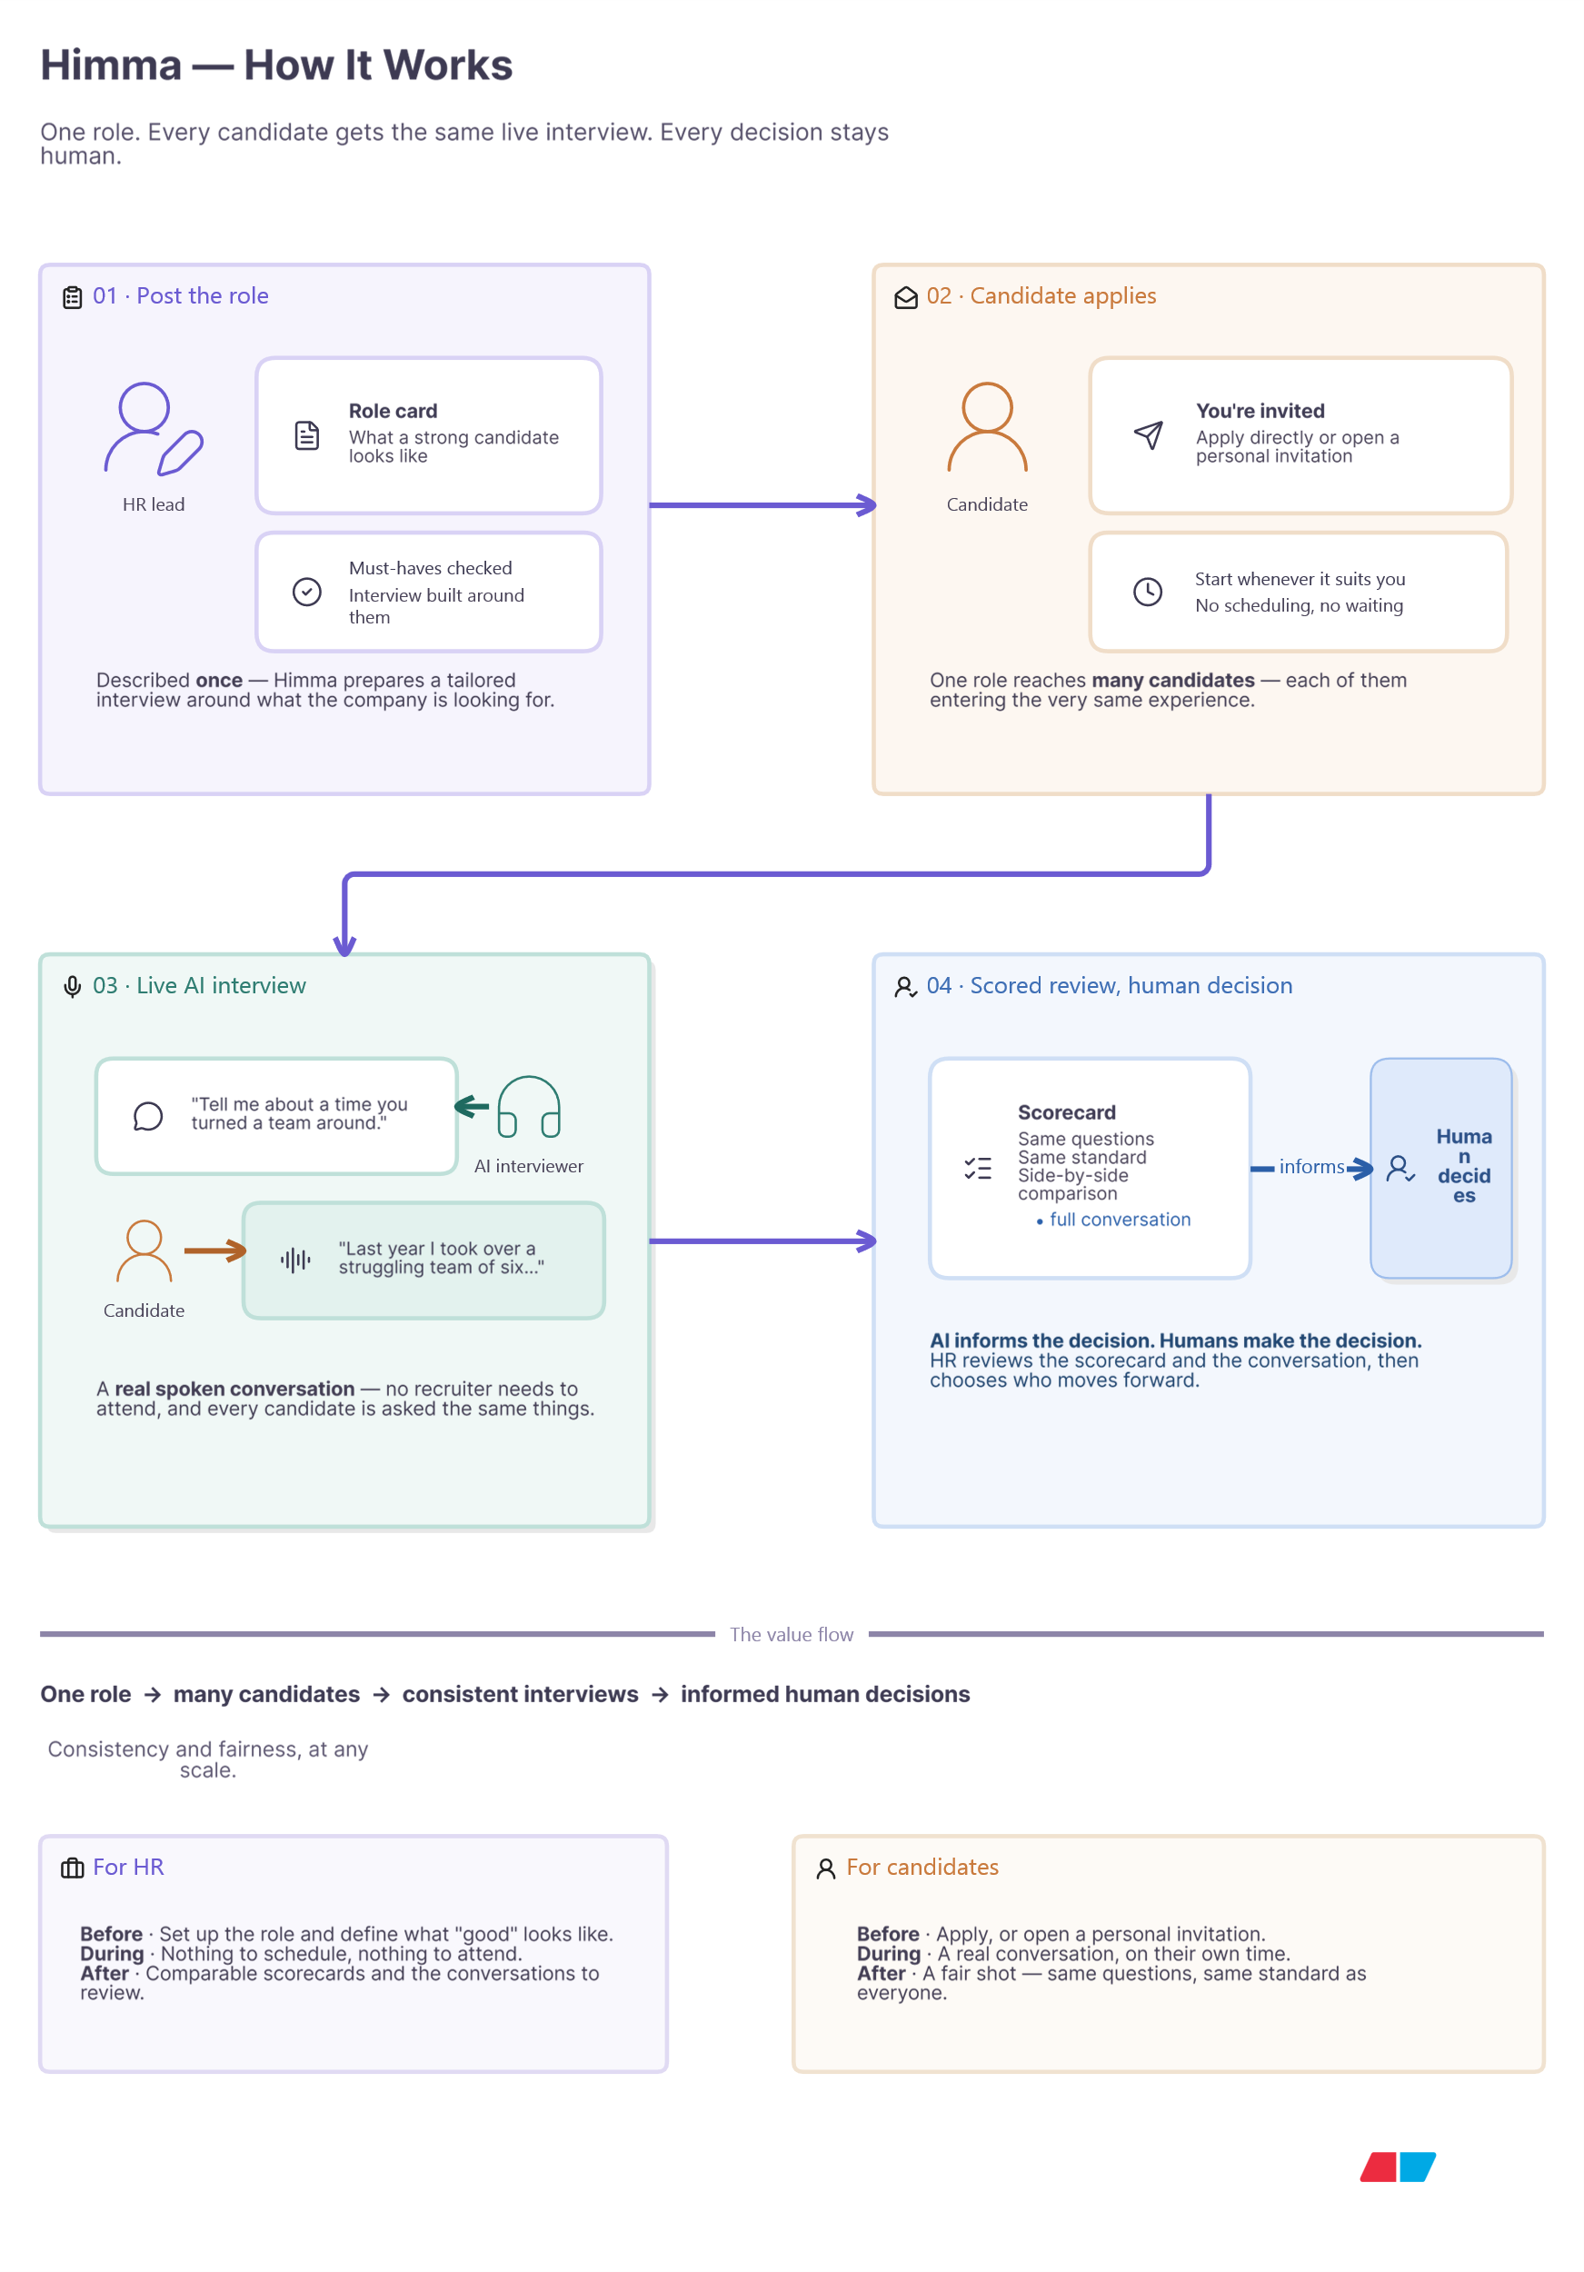

Himma interview platform — tech stack

Concern | Technology | Version
Framework | React | 19.2.8
Build tool | Vite | 8.2.0
Language | TypeScript | ~6.0.2
Routing | react-router-dom | 7.18.2
Styling | Tailwind CSS | 4.3.3
Auth client | @supabase/supabase-js | 2.112.3
Real-time media | livekit-client / @livekit/components-react | 2.21.0 / 2.9.24
Proctoring (face detection) | @mediapipe/tasks-vision | 1.0.1
i18n (EN/AR, RTL) | i18next / react-i18next | 26.4.0 / 17.0.12
Icons | lucide-react | 1.31.0
Testing | Vitest | 3.2.4

Backend (Render, Docker)
Concern | Technology | Version
Framework | FastAPI | 0.141.1
ASGI server | Uvicorn | 0.52.1
ORM | SQLAlchemy (async) | 2.0.52
DB driver | asyncpg | 0.31.0
Migrations | Alembic | 1.19.1
Config | pydantic-settings | 2.15.0
Auth verification | PyJWT (+ Supabase JWKS) | 2.13.0
Supabase client | supabase-py | 2.31.0
LLM client | groq | 1.7.0
LiveKit token/egress API | livekit-api | 1.2.0
Object storage client | boto3 (R2, S3-compatible) | 1.43.85
PDF text extraction | PyMuPDF | 1.28.2
Runtime | Python | 3.13

Agent worker (Railway, Docker)
Concern | Technology | Version
Framework | livekit-agents | 1.7.1
RTC core | livekit | 1.1.15
LLM/STT/TTS plugin (primary) | livekit-plugins-groq | 1.7.1
STT/TTS plugin (fallback) | livekit-plugins-azure | 1.7.1
VAD | livekit-plugins-silero (+ onnxruntime) | 1.7.1 / 1.29.0
LLM client (direct) | groq | 1.7.0
Azure Speech SDK | azure-cognitiveservices-speech | 1.51.2
Runtime | Python | 3.13

Data & identity
Concern | Technology | Version
Database | Postgres (via Supabase, Supavisor pooler) | —
Auth provider | Supabase Auth (JWT, ES256/RS256, JWKS-verified) | —
Guest identity (Flow B) | Locally-issued HS256 JWT | —
RBAC | Custom users_roles table | —

Real-time & AI infrastructure
Concern | Technology | Version
WebRTC SFU | LiveKit Cloud (UAE region) | —
Primary LLM + STT/TTS | Groq (llama-3.3-70b-versatile default) | —
Fallback STT/TTS | Azure Speech | —
Recording storage | Cloudflare R2 (S3-compatible) | —

